

Installation Guide for Online examination file submission system

*November 2022*

Table of Contents

Introduction 3

Purpose 3

Installation Manual 4

Pre-requisites 4

Pre-installation Tasks 4

Required configuration 4

Installing the "WEBDEV Application Server - 10 Connections" 4

Configuration via the Hosting Control Centre 6

Creating a deployment account 9

Installation Procedure 11

Database 11

Practical Project 11

Setup 12

Backup and Recovery of the Practical Project and Database 17

Contact Information 28

# Introduction

## Purpose

The Installation document is to assist a software designer / developer when they create installation instructions for a practical project that is to be installed. And to provide guidelines on the general rules governing the contents.

This procedure is an obligation for a software designer / developer to provide installation instructions in order to reduce possible manipulation mistakes, errors, misinterpretations, loss of time to find the correct information, etc. ..., during the practical project installation phase.

# Installation Manual

The **main components to be described**:

* **Pre-requisites**
* **Install procedure**
* **Backup and Recovery of the Practical Project and Database**

## Pre-requisites

In this section is a **list of install pre-requisites** that must be fulfilled before the install can begin.

**Pre-requisites are of the order of:**

* A windows or Linux server on which the site and database will be deployed
* A dedicated internet connection
* Remote access for the developer to the server

The tools that will be installed on the server to configure and manage the server are supplied with WebDev.

* “WEBDEV Application Server - 10 Connections” tool
* “Hosting Control Centre” tool is installed with the above tool.

**Minimum version of WebDev required is WebDev 23. We will use WebDev 27**

**Minimum Windows OS required is Vista**

**The HFSQL server is available for the following operating systems:**

* **32-bit Windows**
* **64-bit Windows**
* **32-bit Linux**
* **64-bit Linux**

**It is not available for the other operating systems.**

*No other external tools or components are needed as the majority of requirements are handled within WebDev 27 and its added tools.*

## Pre-installation Tasks

### Required configuration

For the deployment on the server, the following elements must be installed and configured:

* A Web server,
* A WEBDEV application server (a 10-connection version is provided with WEBDEV) to Deploy the site remotely (via HTTP). This application server will be installed on a computer other than the development computer. WEBDEV Development version must not have been installed on this computer.

### Installing the "WEBDEV Application Server - 10 Connections"

1. Select the setup language of the WEBDEV Application Server.
2. Accept the license agreement.
3. Choose the "Windows" platform.

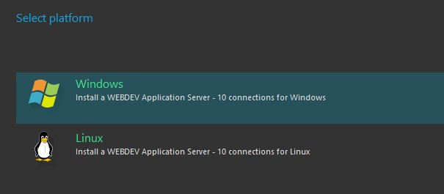

1. Select the installation path of the application server ("C:\WEBDEV 27" by default).

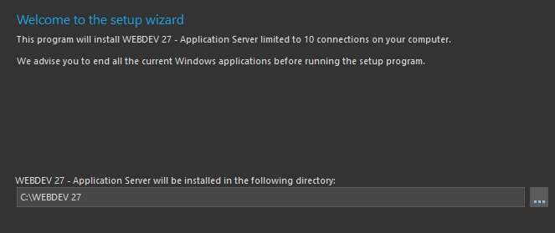

1. The next step allows you to specify the root directory for deploying sites and Webservices.
2. The next allow you to specify the advanced parameters of the WEBDEV application server.

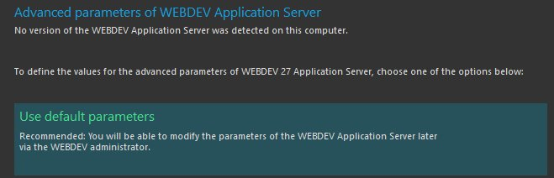

1. The next step proposes the hosting of sites from previous versions.
2. **If the WEBDEV Application Server has never been installed**, the parameters of a Windows account can be specified that will be used as WEBDEV administrator. This account will also be called "Hosting account".  
   You can create a new Windows account or use an existing Windows account.
3. **If a previous version of the WEBDEV Application Server has been installed on the computer**, the wizard allows:
   * defining the management of sites and webservices of earlier versions
   * importing WEBDEV accounts. Specify the settings of a Windows account that will be used as WEBDEV administrator. This account will also be called "Hosting account".  
     You can create a new Windows account or use an existing Windows account.
4. The next step is used to manage the hosting of SaaS sites. The SaaS activation automatically installs a site and a Webservice to manage your SaaS sites.
5. The next step allows defining the need for a secure connection to access all administration sites.
6. The next step allows you to select the language of the application server that will be installed. The Application Server is available in 3 languages: english, spanish, french.
7. If the computer contains several virtual servers, select the Web servers on which the WEBDEV Application Server must be installed.
8. "WEBDEV Application Server - 10 connections" is automatically configured. WEBDEV sites can be deployed immediately.
9. The WEBDEV administrator and the Hosting Control Centre are automatically started.

### Configuration via the Hosting Control Centre

When the "WEBDEV Application Server - 10 Connections" is installed, a Windows account is created or defined as administrator of the WEBDEV Application Server. This user has all the rights (administration, deployment, statistics).

We will use the Hosting Control Centre to configure the different characteristics of this user to deploy the site.

### Creating a deployment account

The Hosting Control Centre will also be used to create a deployment account.

This account can be used to deploy WEBDEV sites from WEBDEV.

1. Click the "New user" button. The user creation wizard starts. Simply follow the different steps.
2. You can:
   * Create a Windows account. This account will be used for deploying and configuring your sites.
   * Use an existing Windows account.

Type the username and password (you can also generate the password. In that case, don't forget to write it down).

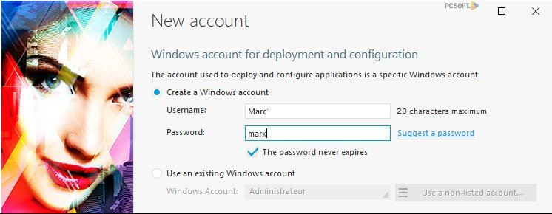

1. The wizard proposes the WEBDEV options associated with the account:

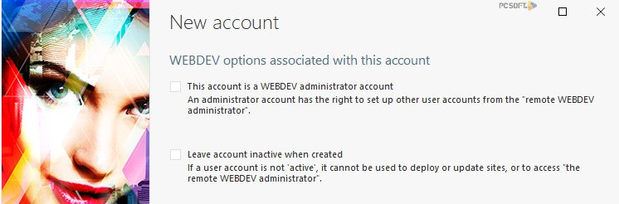

1. The wizard proposes to use a Windows account to run the applications.
2. Type the information regarding the user.
3. The directories of the user account are automatically filled according to the specified data.

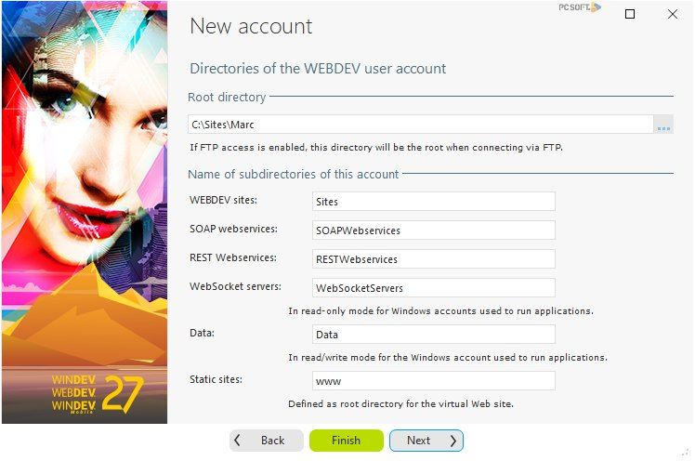

1. Continue with the wizard until you reach the "Virtual Web site" step.
   * If you choose to create a new virtual site, simply enter the DNS name that will point to this site (the DNS must also be configured).
   * If you choose to use an existing virtual site, its configuration will be replaced.
2. This step specifies whether FTP access and deployment should be allowed for the user. In our case, this option is not necessary because we will perform an HTTP deployment.
3. The wizard is finished. Check all choices. You can uncheck the operations you don't want the wizard to perform for you.
4. Validate the wizard. Your server is now ready to receive WEBDEV sites. We will use the user we created to deploy THE site via HTTP.

## Installation Procedure

### Database

The HFSQL Client Server data files are created on first run of the system site once deployed. The HCreationIfNotFound("*") procedure is used to do so after a connection to the HFSQL Client Server has been established.

The following code is used to establish the connection:

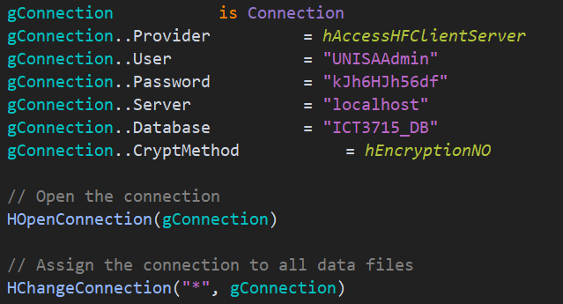

After the site has started on the server the first time, the database contents can be loaded in multiple ways, we will handle the upload in the following manner:

A simple Home page with some of the project details to start off with opens up. A Login button is visible that redirects the user to the login page.

The Login page consists of a simple user number and password input fields. Added are details for different login users but at this stage we are going to concentrate on the UNISA Admin Login details. After the details are entered and validated, an admin session is created, and the user is directed to the Admin Dashboard page.

Once the Admin user is logged in, a file path edit field and 7 buttons are visible. The edit field is used to input the cleaned data in the csv file’s location on the admins directory. After this field is added and valid, the user can start uploading the data, one table at a time, by simply selecting the buttons for the relevant table.

On each button select, a popup message appears that informs the Admin user that the process may take some time. When the user selects the Ok button, the process starts and once it ends, the popup closes, allowing the Admin user to select the next data import button or logout.

Another way to is to make a database backup of the database, add it to the UNISA HFSQL Client Server and Restore it directly to the server. (This option is discussed later on.)

### Practical Project

WEBDEV includes a setup wizard that allows you to easily install your site at the hosting company (Internet or Extranet site for example) or on one of your servers dedicated to WEBDEV hosting (Intranet site for example).

* We are going to use this wizard:
  1. In the ribbon, on the "Project" tab, in the "Generation" group, expand "Deploy site" and select "Generate and deploy site".

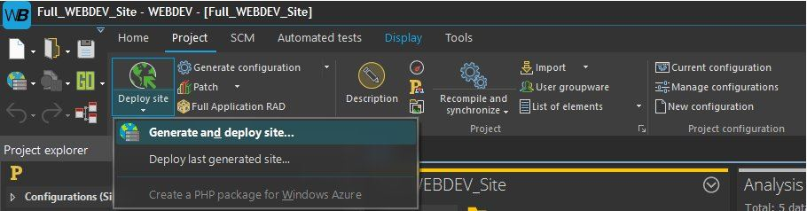

* 1. The wizard starts. Before performing the setup, all elements found in your site must be included in a library. A library is a file that contains all elements created during the development steps (database description, pages, reports, queries, etc.). The HTML pages and the images are not included in the library.

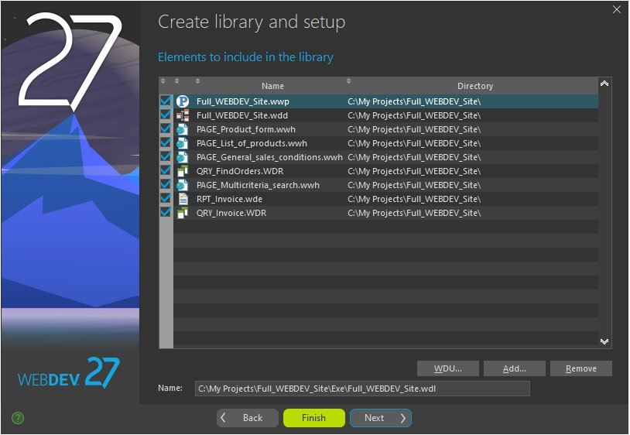

* 1. Several languages can be included in the library.
  2. The information about the library version is used to enter the elements that will be displayed in the file properties in the Windows explorer.
  3. Don't save the project and validate the library creation.

### Setup

The setup wizard will now ask you some questions to define how your site will be deployed. In our case, we are going to perform a remote installation via HTTP:

* 1. Select "Deploy to a remote WEBDEV Application Server".

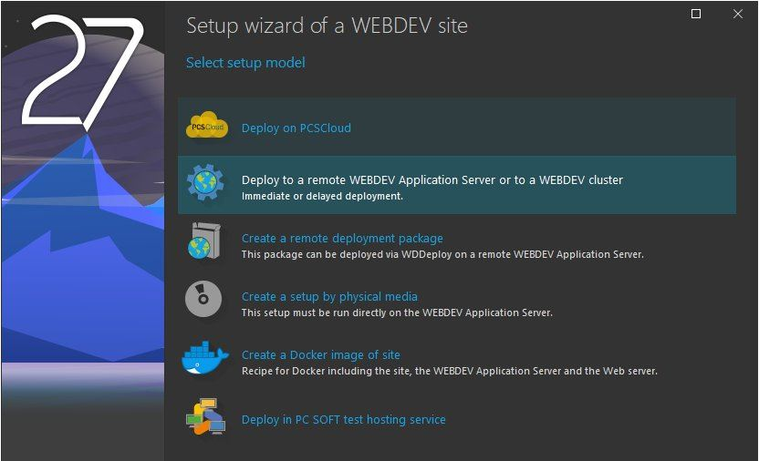

* 1. To define the server parameters, the following information must be provided by your hosting company.
     + Server address (in this example, name of the computer where the "WEBDEV Application Server - 10 connections" was installed):
       - a computer name accessible by network (for example: "TestServer"),
       - an IP address (for example: 192.168.15.99),
       - an Internet address (for example: www.myserver.eu).

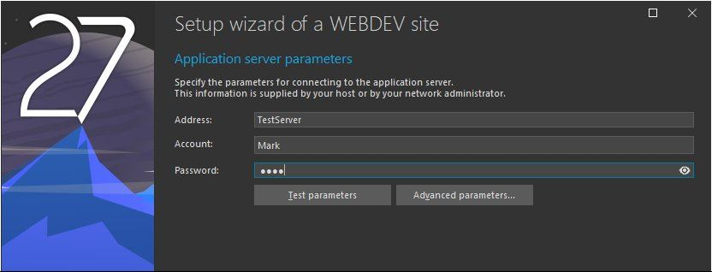

* + - User account that runs the setup. We created it in the previous step: this account is "Mark".
    - Password associated with the account (in this example, also "mark").
  1. Type the parameters for site deployment.

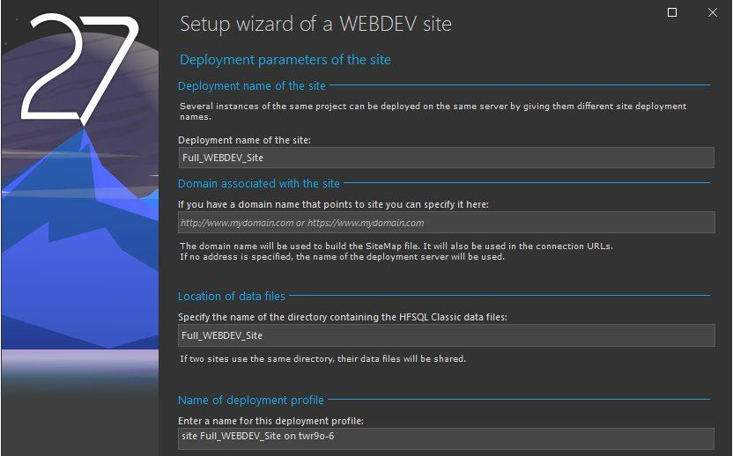

* 1. WEBDEV establishes the connection and it summarizes the operations to perform (number of files to update, number of files to delete, etc.). To get the details of the operations and modify them if necessary, click "Edit list of files".

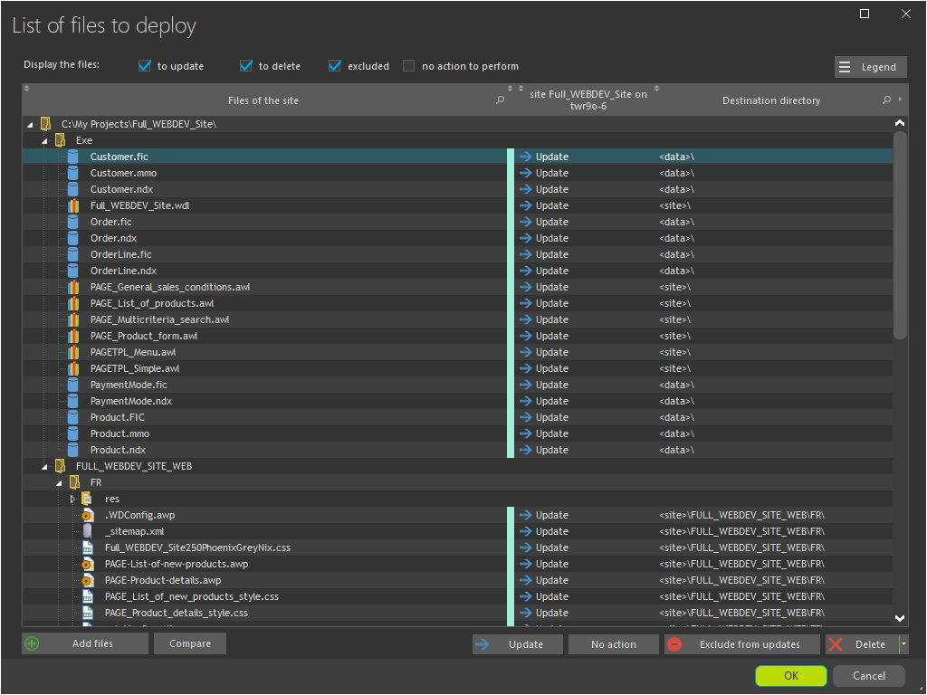

* 1. The wizard proposes to include the automatic modification of data files in the setup. You can also configure the elements required to use an HFSQL Client/Server database.

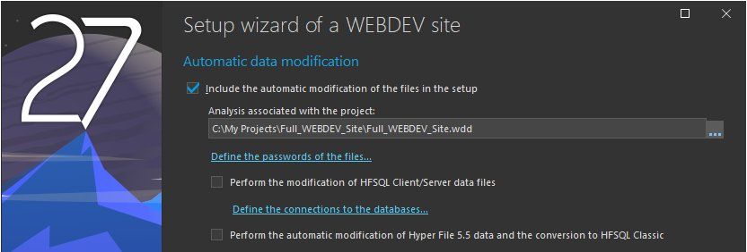

* 1. The wizard proposes to select the deployment mode:
     + Deploy without disconnecting users. This option allows you to update the site without disconnecting the users.
     + Deploy by disconnecting users. If this option is selected, connected users will be automatically disconnected to update the site.
  2. Specify the site parameter:

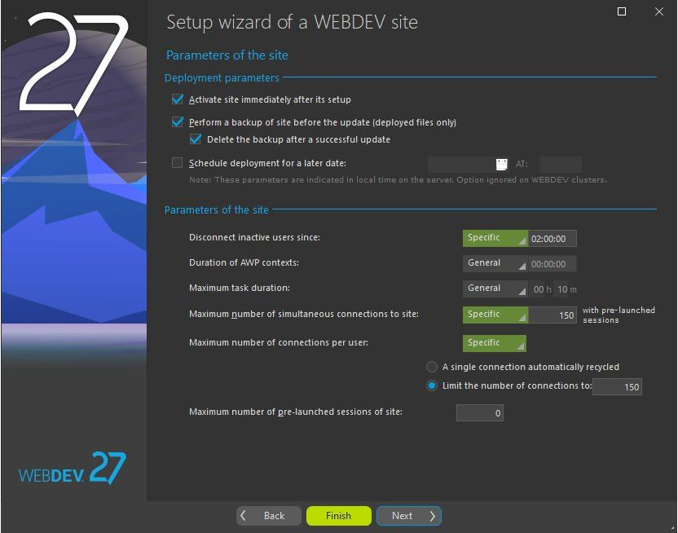

You can modify:

* + - The maximum number of connections to the site: if this value is set to "5" for example, only 5 users will be able to connect to your site at the same time.
    - The maximum number of connections per user: if you set this value to "5" for example, a user will be able to start your site up to 5 times.
    - The amount of idle time before user disconnection: this option allows to free all resources used by the user's session if the user has not performed any action for the specified time.
  1. By default, your site is immediately enabled after setup. The users will have no access to your site if "Activate site immediately after its setup" is unchecked.
  2. The wizard proposes to perform:
     + an immediate setup: the files will be immediately transferred to the server and your site will be immediately installed.
     + a delayed setup: the files will be immediately transferred to the server but your site will be installed at the specified date and time ("Schedule deployment for a later date").
  3. The wizard allows you to define the parameters for site security: Change of IP and more.
  4. The wizard proposes to automatically generate the statistical files for the site. These statistics affect for example the actions performed on the site, the origin of Web users, and more.
  5. Validate the setup ("Finish"). The setup wizard transfers the files.

During the file transfer, the wizard compresses and encrypts the transferred data. Your data is transferred with a high-security level.

At the end of setup, a link allows you to immediately start the site.

## Backup and Recovery of the Practical Project and Database

**Database Backup**

WEBDEV HFSQL Control Centre, allows for easy Database backup and recovery on the server in HFSQL Client/Server. To backup the database, will follow the following steps:

1. In WEBDEV, select the HFSQL icon in the Tools tab.

1. This opens the HFSQL Control Centre where you can connect to my HFSQL server and view the database. After you input the relevant data and press Ok, you enter the Command Centre.

1. Once the HFSQL Control Centre is open, select the Backups Tab.

1. This opens the Backups internal window. Here, previous backups can be handled.

1. To create a backup, select the New backup option.

1. The Create Backup window is displayed. This is a hot backup, where a specific backup can be done. Scheduled backups are available. Use the hot backup as your main backup thus making sure it is performed especially before and after large changes. The hot backup window gives you different backup options, you will be making a specific database backup.

1. After selecting my database to back up, you can choose how the backup will be stored, make use of the default settings.

1. Select a directory where the backup will be saved. After the backup is done, copy and paste the backup folder in different directories, one of which is my UNISA OneDrive file so there are multiple copies available to you, allowing you to be ready for any crashes that may occur. Select the date and time to be added to your backup file.

1. The following window allows for advanced additions to your backups. For your project, this is not necessary so we will move on.

1. This window indicates the settings process is done and on Finish selected the backup will initiate.

1. The backup starts and its progress can be viewed in the Backups window.

1. Once finished, the backup’s success can be viewed in the main panel.

**Database Restore**

1. Restoring a backup can be done from the same window. Simply select the Restore Option and select a restore option, we will restore the backup we just made, It is already selected.

1. A popup window appears with some basic information regarding the restore. We have no active user connections so we can continue.

1. Once the Restore is done, a confirmation message is displayed.

1. As stated, you created a schedule backup for every day after you have worked on your database. The procedure described above is followed to do so with only the added option of setting the schedule.

**Project backup and recovery**

You will do this with WEBDEV’s SCM (Source Code Manager). The SCM uses a repository that contains all the sources of your project: procedures, classes, windows, pages, reports, components, analyses, etc. The SCM allows us to manage the history of modifications and versions and allows me to work remotely as my SCM repository will be saved on a cloud server in HFSQL Client/Server mode. This will make backup and restore, simple and easy.

**Connecting to the SCM**

1. In the project SCM tab is the Add Project to SCM option.

1. This option opens the repository window. To add my project to the remote repository, you selected the HFSQL Client/Server option.

1. You then entered the details required to link your project to a new repository on a cloud server.

1. After connecting to the repository, you can add folders and subfolders where you can store multiple projects.

1. Select the elements of your project you want to add, in our case we added all of them.

1. Select the dependencies of my project you want to add, in our case we added all of them.

1. Then a final window finalizes my project addition to the repository.

1. After your project was successfully added, the following toolbar appears that allows you to retrieve, change, delete, update and check your project history.

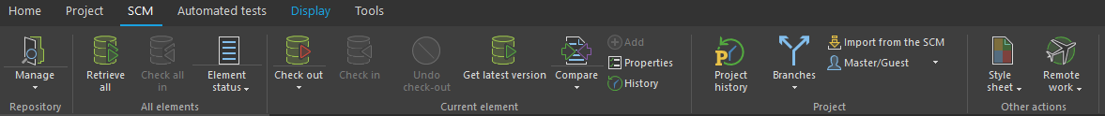

1. The Check out option allows you to retrieve, for example, the Login page, change some code and check the element back in to the repository with the Check in option.

1. The Check out window allows for multiple options of check out, keep the default value and continue.

1. To view your project history, you can select the Project History option.

1. This option allows you to view, compare, and retrieve previous versions and changes made for when, for example, I have made a grave mistake and want to revert back to a previous save.

The SCM allows you to handle your project remotely from anywhere and have access to previous versions and element modifications that allows for easy restore. Its basically an auto project backup system that also keeps your project safe and ready for you to restore anything, anytime.

## Contact Information

|  |  |
| --- | --- |
| Software designer / developer | |
| Name | Ralph |
| Surname | Botes |
| Contact number | +27 79 971 9978 |
| E-mail address | 65614968@mylife.unisa.ac.za |